NMAM INSTITUTE OF TECHNOLOGY, NITTE
DEPARTMENT OF INFORMATION SCIENCE AND ENGINEERING

OPERATING SYSTEMS
ASSIGNMENT REPORT
Readers-Writers Problem and Dining Philosophers Problem
Semaphore-based and Monitor-based Solutions in Java

SUBMITTED BY
Name: Kruthi N
USN: NNM24IS112
GitHub: https://github.com/kemcho-7/OS-Task2-Synchronization-Assignment

SUBMITTED TO
Dr Jason Elroy Martis
Associate Professor
Department of Information Science and Engineering

Abstract
This assignment implements two classic operating-system synchronization problems in Java: Readers-Writers and Dining Philosophers. Each problem is implemented using semaphore-based coordination and monitor-style coordination. The Readers-Writers implementation coordinates three reader threads and two writer threads that share an integer value. The Dining Philosophers implementation models four philosophers and four chopsticks.
The program was compiled using OpenJDK 21 in the VS Code PowerShell terminal. All four menu options were executed and their completion messages were observed. Actual terminal screenshots are included in this report. The project also includes an interactive HTML event visualizer that lets the reader step through the captured output traces for all four options. The HTML view replays the recorded trace; it does not control the running Java threads.

1. Problem Statement
Implement the Readers-Writers problem using semaphores and monitors, and implement the Dining Philosophers problem for four philosophers and four chopsticks using semaphores and monitors. The program should coordinate concurrent activities, protect shared resources, and provide readable output for understanding the synchronization behavior.

2. Objectives
- Understand the need for synchronization when multiple threads share data or resources.
- Implement Readers-Writers with semaphores and a monitor-style solution.
- Implement Dining Philosophers for four philosophers and four chopsticks using both methods.
- Observe mutual exclusion, concurrent reading, resource acquisition, release, and thread state changes.
- Compare both approaches and validate the four implementations through execution output.
- Provide an HTML visualizer for reviewing recorded events step by step.

3. Synchronization Fundamentals

3.1 Thread and critical section
A thread is an independent path of execution in a process. A critical section accesses shared data or a shared resource, so concurrent access must be coordinated to prevent conflicting operations.

3.2 Semaphore
A semaphore is a synchronization primitive that controls access using acquire and release operations. A binary semaphore can guard a resource so only one thread holds it at a time. A counting semaphore can limit the number of threads that enter a region.

3.3 Monitor
A monitor combines shared state and methods that control access to it. In Java, synchronized methods or blocks provide mutual exclusion. The wait/notify mechanism can coordinate threads based on conditions; after waking, a thread should re-check the condition.

3.4 Race condition, deadlock and starvation
A race condition occurs when the outcome depends on uncontrolled thread timing. Deadlock is indefinite waiting caused by a cycle of resource dependencies. Starvation occurs when a thread is repeatedly denied access. Deadlock prevention does not automatically guarantee fairness.

4. Readers-Writers Problem
Readers only inspect the shared value, so multiple readers may read at the same time. Writers modify the shared value and must have exclusive access. A writer should not overlap with active readers or another writer.

4.1 Semaphore solution: algorithm
- Initialize a mutex semaphore to protect the reader counter and a resource semaphore to guard the shared data.
- When a reader enters, acquire the counter mutex and increment the active-reader count.
- The first reader acquires the resource semaphore, preventing writers from entering while readers are active.
- After reading, each reader decrements the counter under the mutex.
- The last reader releases the resource semaphore.
- A writer acquires the resource semaphore, increments the shared value, and releases the semaphore after writing.
Observed output: Reader 2, Reader 3, and Reader 1 read value 0 with active-reader counts 1, 2, and 3. After all readers finish, Writer 2 writes value 1 and Writer 1 writes value 2. The order of thread messages can vary across runs.

4.2 Monitor solution: algorithm
- Maintain activeReaders, writerActive, and sharedValue in the monitor.
- A reader waits while a writer is active, then increments activeReaders.
- When a reader finishes, it decrements activeReaders and notifies waiting threads if the count reaches zero.
- A writer waits while another writer is active or any reader remains.
- The writer marks itself active, updates the shared value, then clears writerActive and notifies waiting threads.
Observed output: all three readers finish before Writer 1 writes value 1 and Writer 2 writes value 2. The output confirms sequential writer updates in this recorded run.

5. Dining Philosophers Problem
Four philosophers sit around a circular table with four chopsticks. Each philosopher alternates between thinking and eating. To eat, a philosopher must acquire the chopsticks on both sides. Neighboring philosophers share a chopstick, so the implementation must prevent simultaneous conflicting use.

5.1 Semaphore solution: algorithm
- Create four binary chopstick semaphores, one per chopstick.
- Create a room semaphore with three permits, limiting the number of philosophers that attempt to acquire chopsticks at once.
- Each philosopher thinks, becomes hungry, acquires a room permit, and acquires both adjacent chopsticks.
- The philosopher eats and records the event.
- In a finally block, release any chopsticks and room permit that were acquired.
Observed output: P1 eats using chopsticks 1 and 2 while P3 eats using chopsticks 3 and 4. These pairs are disjoint. After they finish, P4 and P2 eat using chopsticks 4 and 1, and 2 and 3.

5.2 Monitor solution: algorithm
- Maintain each philosopher's state as THINKING, HUNGRY, or EATING.
- When a philosopher requests chopsticks, mark the philosopher HUNGRY.
- Check whether both neighboring philosophers are not EATING.
- If both chopsticks are available, set the philosopher's state to EATING; otherwise wait.
- After eating, return to THINKING and notify waiting philosophers to re-check their conditions.
Observed output: P3 and P1 start eating first. After they finish, P4 and P2 start eating. The program prints the monitor completion message.

6. Program Execution and Output Interpretation
The program is menu-driven. Option 1 selects Readers-Writers using semaphores, option 2 selects Readers-Writers using a monitor, option 3 selects Dining Philosophers using semaphores, and option 4 selects Dining Philosophers using a monitor. Compile and run from the project root with the commands below.
- javac src/OSSynchronization.java
- java -cp src OSSynchronization
Each run prints a completion message and reports that execution_log.txt was saved. That file represents the most recently selected implementation because it is overwritten on the next run. The screenshots document the observed run order; Java's thread scheduler may produce a different order on later runs.

7. HTML Event Visualizer
Open synchronization_visualizer.html in a web browser. Select one of the four tabs, then use Previous, Next, or Reset to review its event trace. The event list can also be clicked to jump to a particular event. The visualizer provides a simple explanation of each implementation and indicates the current event and progress through the trace.
The event sequences are based on the terminal outputs captured for this assignment. The HTML file is a trace visualizer, not a live connection to Java threads. To refresh the visualization after a new run, update its event data using the new execution log.

8. Actual Execution Screenshots
The following screenshots were captured from the Java program running in VS Code. Each corresponds to one of the four menu options.

8.1 Readers-Writers using Semaphores (Option 1)
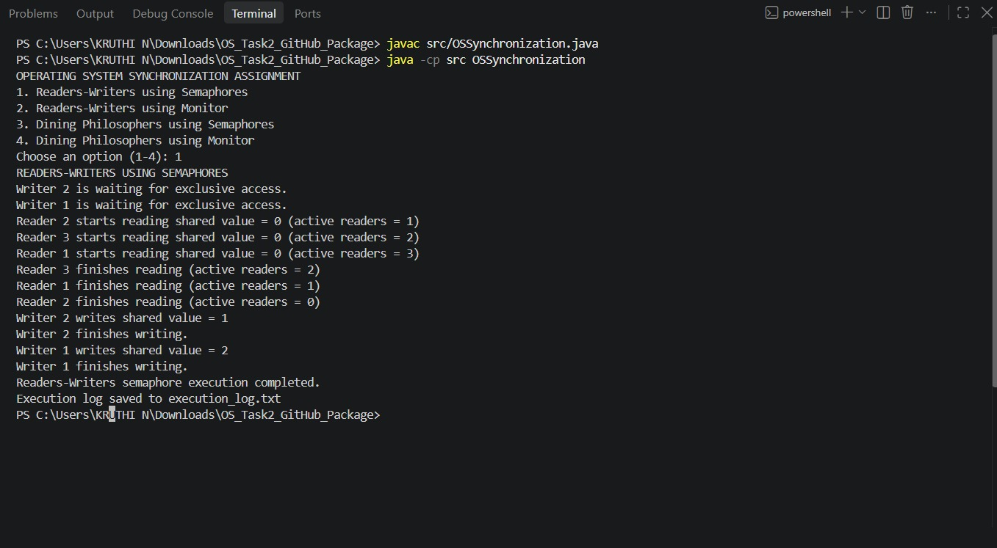
Figure 1. Readers-Writers semaphore output.

8.2 Readers-Writers using Monitor (Option 2)
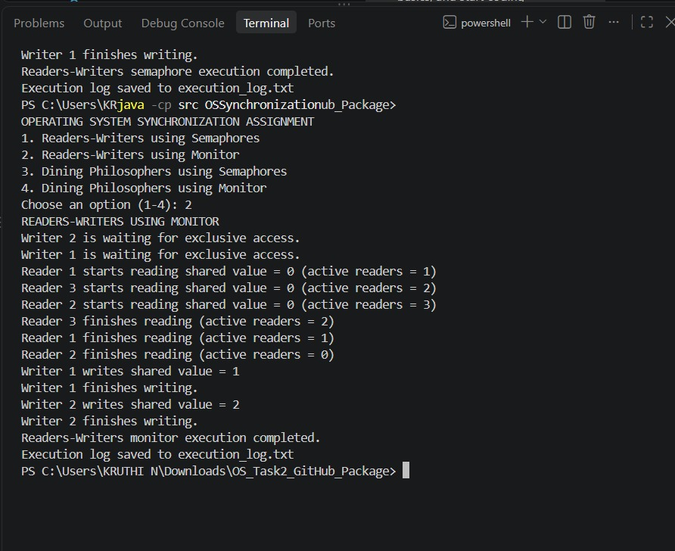
Figure 2. Readers-Writers monitor output.

8.3 Dining Philosophers using Semaphores (Option 3)
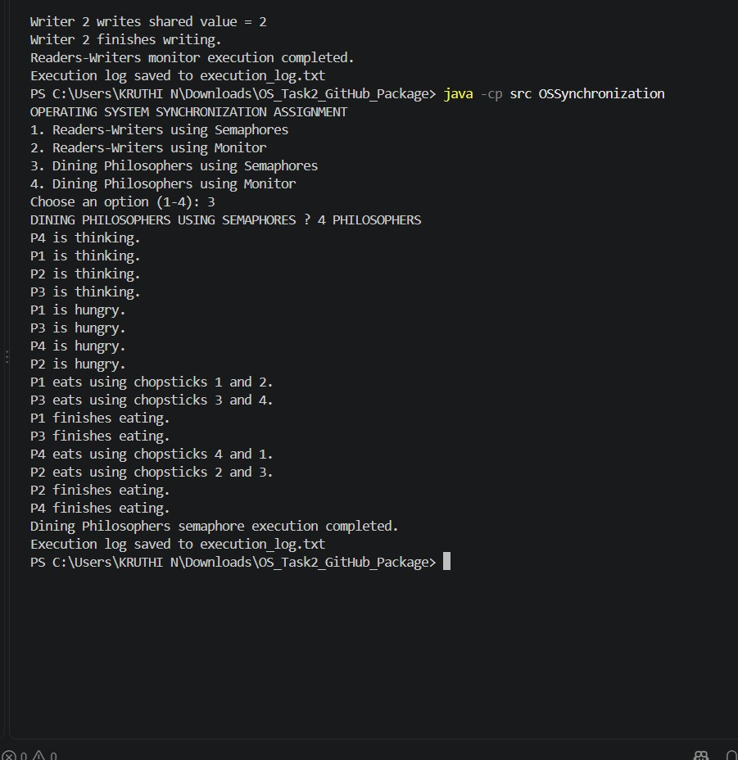
Figure 3. Dining Philosophers semaphore output.

8.4 Dining Philosophers using Monitor (Option 4)
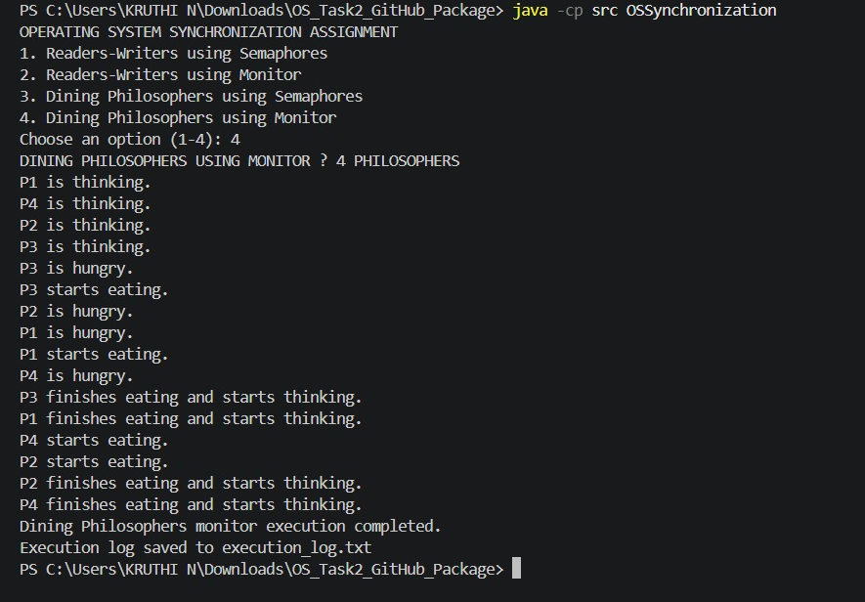
Figure 4. Dining Philosophers monitor output.

9. Semaphore and Monitor Comparison
Aspect | Semaphore approach | Monitor approach
Structure | Uses explicit acquire/release operations. | Groups state and access rules.
Waiting | Thread may block acquiring a semaphore. | Thread waits until a condition is satisfied.
Resource handling | Programmer must pair acquisitions and releases correctly. | Monitor methods centralize state transitions.
Readability | Resource ordering is visible but must be managed carefully. | Encapsulation can make conditions easier to inspect.
Fairness | Depends on semaphore and implementation policy. | Depends on condition policy and scheduling.
Verification | Inspect semaphore acquisitions/releases and trace. | Inspect state changes, waits, notifications and trace.

10. Testing and Validation
- Compiled with javac src/OSSynchronization.java; compilation returned without errors.
- Option 1 completed with “Readers-Writers semaphore execution completed.”
- Option 2 completed with “Readers-Writers monitor execution completed.”
- Option 3 completed with “Dining Philosophers semaphore execution completed.”
- Option 4 completed with “Dining Philosophers monitor execution completed.”
- Each recorded run reported that execution_log.txt was saved.
- The HTML visualizer opens locally and provides four trace tabs and step controls.
These checks confirm that the four recorded executions completed. They do not constitute a formal proof that every possible schedule is free from deadlock or starvation. Repeat runs and inspect the code if stronger guarantees are required.

11. Conclusion
This assignment demonstrates semaphore-based and monitor-style solutions to Readers-Writers and Dining Philosophers. The Readers-Writers traces show concurrent reading and sequential writing. The Dining Philosophers traces show four philosophers acquiring neighboring chopsticks and completing their eating phase. The HTML event visualizer provides a readable step-by-step view of the recorded outputs. All four Java options were executed successfully in the reported tests.

AI Usage and Development Support
AI assistance was used to help structure the report, explain synchronization concepts, and build the HTML trace visualizer. The Java source was compiled and executed locally, and the screenshots included in this report come from the actual terminal runs. The student should review the source code and understand the algorithms and limitations before submission.

References
- Oracle, Java Platform, Standard Edition Documentation. https://docs.oracle.com/en/java/
- Silberschatz, A., Galvin, P. B., and Gagne, G. Operating System Concepts.
- Tanenbaum, A. S., and Bos, H. Modern Operating Systems.
- Downey, A. B. The Little Book of Semaphores. https://greenteapress.com/wp/semaphores/
- Hoare, C. A. R. “Monitors: An Operating System Structuring Concept.” Communications of the ACM, vol. 17, no. 10, 1974.

